**News Tracker Application PNT2022TMID38083**

**SETTING UP APPLICATION ENVIRONMENT CREATE FLASK PROJECT**

# Six Steps have been followed to create Flask Project.

The Steps that we have followed have been described below

**Step 1.** Install Python latest version from python.org

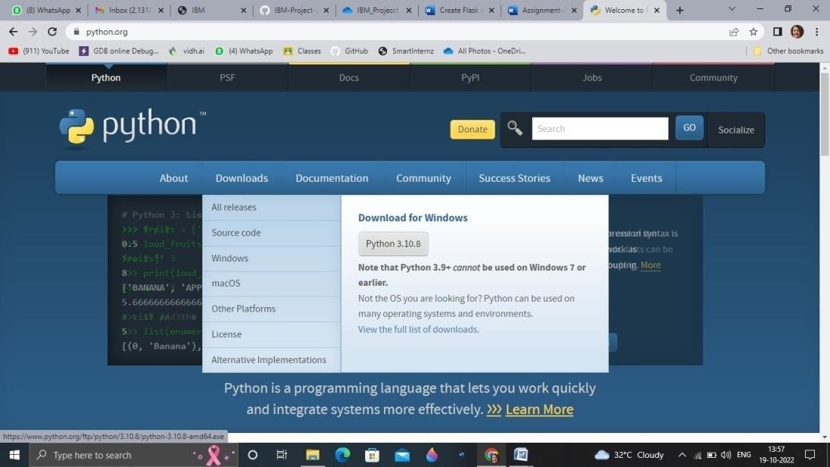

**Step 2**. Download Anaconda from https://[www.anaconda.com/](http://www.anaconda.com/) and install it byrunning the .exe file



**Step 3**.Install Flask using command pip install flask

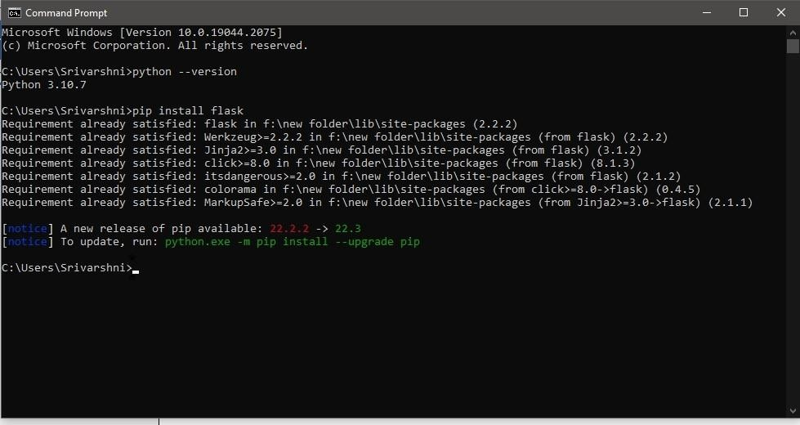

**Step 4**.Open a new Python file and start coding from flask import

Flask app = Flask( name ) @app.route('/')

def hello():

return “Hello World” if name == ' main

': app.run(debug=True)

**Step 5**. Run the Python file using command python filename.py

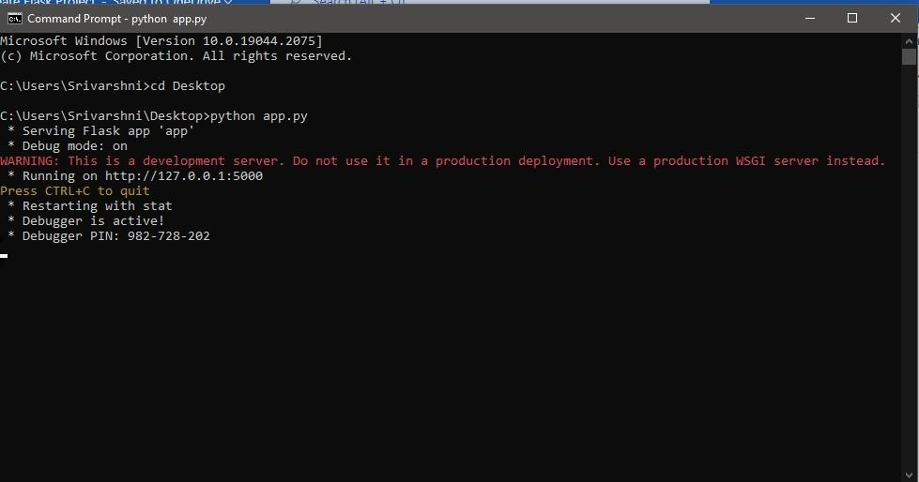

**Step 6**: Open the Ip in browser

